Wellness Lesson 1

Corresponding video- Just Breathe. <https://www.youtube.com/watch?v=RVA2N6tX2cg>

**Activities:**

* Feelings check in – Have students report how they are feeling today.
* Use this feeling chart to help students identify how they are feeling.

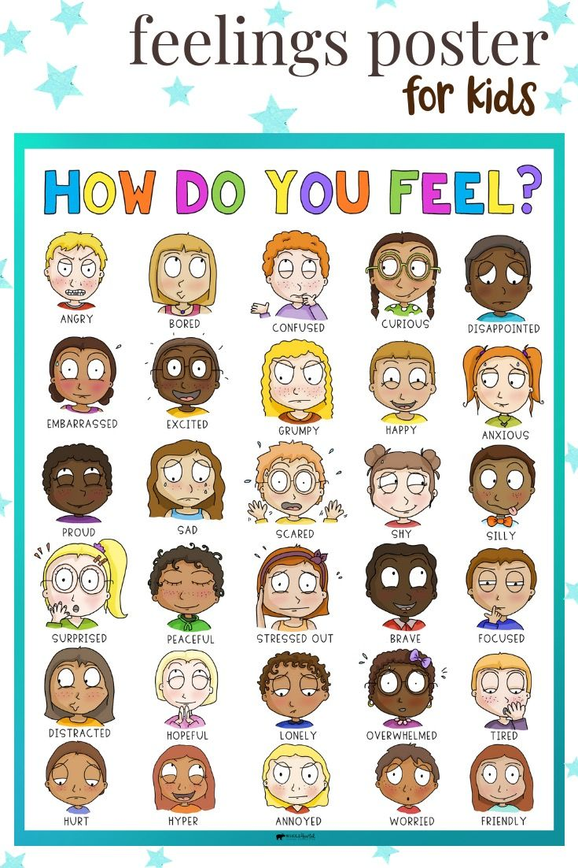

Then ask some follow up questions…begin by asking your child or children to give feedback as to why they might be feeling happy, sad, mad, ect.

Thank them for sharing with you. Now, let’s practice some breathing!

**Breathing Exercise Options**:

*For the best results breathe in through the nose for a full count of 4 (1,2,3,4) Hold, breathe out through the mouth slowly for full count of 4 (1,2,3,4)

* Star Breathing- Follow the pattern of a star- breathe in on the incline, hold at the point and exhale on the decline. This image can help with this.

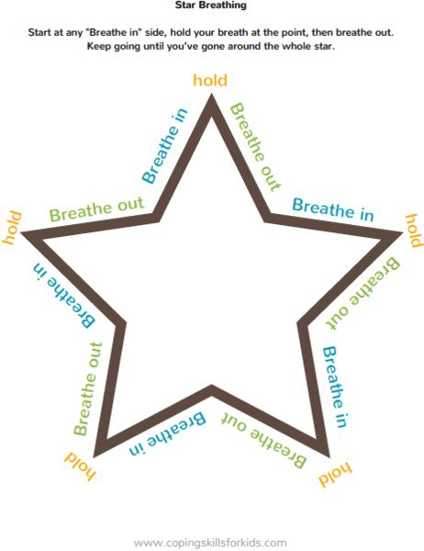

* Belly Breathing- Students can lay down (some may put a stuffed animal on their bellies) the intention is to see the belly fill and deflate with the breath.
* Balloon Breathing- Imagine filling a balloon while exhaling

(Many students have learned some amazing breathing tricks at school already…..have them show you or teach you what they know) Practice along with them. Afterall… we can all benefit from a moment of peace.

**Challenges for parents**:

* Report your feelings with your child (It’s okay to be honest here….children learn best from you ☺) Share how you are feeling and give a brief reason why you might be feeling this way. You may be surprised at some solutions for difficult emotions (like anger) that your students have for you and their willingness to make it better.
* You can also ask children what has helped them to feel better when they are angry, confused or sad? Or use this as an opportunity to talk about times when they weren’t feeling their best and things that they can do differently next time to turn it around.